Nepal College of Information Technology
Unit Test
Fall 2011
Program : BE IT Time : 2 hrs
Semester : Fall (III) FM : 70
Subject : Electronic Circuits-I PM : 35

- Candidates are requested to give their answer as far as practicable in their own words.
- The figure in the margin indicates the full marks
- Attempt ALL question Assume Practical values if Necessary

1 a) Draw the common Emitter amplifier and its small signal equivalent circuit model. Derive expression of voltage gain, current gain, input impedance and output impedance. (8)
b) Calculate the output voltage in CC amplifier circuit shown below. (8)
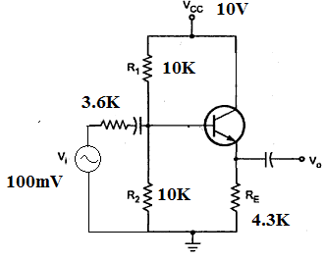
2. a) Why cascading is required? Derived the expression of n-stage cascaded amplifier. (7)
b) Why Common Collector configuration amplifier is also called emitter follower? Verify your answer with the help of circuit diagram and necessary derivation. (8)
c) Why Darlington pair is also called super beta transistor? Find the effective β, and input resistance(r_{in}) of Darlington pair. (8)
3. a) Draw a two stage RC coupled amplifier circuit. Discuss the influence of input and output coupling capacitor on frequency response. (8)
b) Determine the value of lower cutoff frequency for the circuit shown below. Assume re = 20ohm, ro=80Kohm, Ci=10µF, Co=10µF and Ce=47µF. (7)
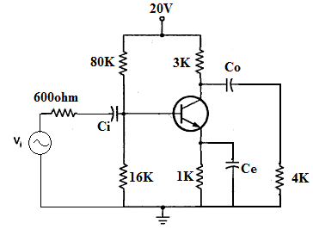
4. a) What is Miller-Effect? Prove that C_{M}=C_{C}(1-A_{V}), where CC is capacitance connected between the input and output of an amplifier, AV is voltage gain and CM is miller capacitance. How this affects the high frequency response of inverting amplifier. (8)
b) Write the effect of emitter bypass capacitor on the Low frequency response. What will be the effect on the gain when we removed the bypass capacitor in common Emitter Configuration. (8)

